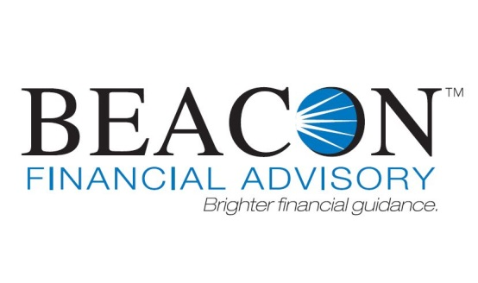

Financial Advisor

Thomas Michael Genco Pease & Associates Suite 400
1422 Euclid Ave.
Cleveland, OH 44115
Phone: (216) 348-9600

Registered Investment Advisor

Beacon Financial Advisory LLC
25825 Science Park Drive, #110
Cleveland, OH 44122
216-910-1850

03/01/2018

This brochure provides you with information about your Financial Advisor, Thomas Michael Genco, who is registered with Beacon Financial Advisory, LLC. This brochure is a supplement to both the Form ADV 2A brochure which you should have already received.

Additional information about your Financial Advisor is available via the U.S. Securities and Exchange Commission's website at www.adviserinfo.sec.gov.
Please Note: If you have not received a copy of the Form ADV 2A brochure,, please contact Deborah L. George, Designated Supervisor, at (216) 910-1850. Brochure requests and additional questions may also be directed to 216-910-1850.

EDUCATIONAL BACKGROUND & BUSINESS EXPERIENCE
Thomas Michael Genco Year of Birth: 1960

Education
Cleveland State University, Bachelor of Business, 1983

Business Experience
Financial Advisor, Capital Analysts,, June 2012 - Present
Registered Representative, Lincoln Investment, , June 2012 - Present Financial Advisor, Capital Analysts, Incorporated, 2010 - June 2012 Registered Rep, SMH Capital Inc., 2007 -2010
Registered Rep, Lincoln Financial Advisors, 1998 - 2007

Professional Licenses/Designations
Mr. Genco holds and maintains the appropriate securities and insurance licenses and registrations required to engage in the offering of securities and insurance products.
In addition, Mr. Genco holds and maintains the following professional designation(s):

Certified Financial Planner (CFP®)
Designation Status: Currently offered and recognized by the issuing organization Issuing Organization: Certified Financial Planner Board of Standards, Inc.
Prerequisites/Experience Required: Candidate must meet the following requirements:
A bachelor’s degree (or higher) from an accredited college or university, and three years of full- time personal financial planning experience
Educational Requirements: Candidate must complete a CFP-board registered program, or hold one of the following: CPA, ChFC, CLU, CFA, Ph.D. in business or economics, Doctor of Business Administration, Attorney's License
Examination Type: CFP Certification Examination
Continuing Education/Experience Requirements: 30 hours every two years

DISCIPLINARY INFORMATION
Mr. Genco has no material legal or disciplinary events to report.

OTHER BUSINESS ACTIVITIES

Mr. Genco is a registered representative of Lincoln Investment, a registered broker- dealer. Your advisor may offer the broker-dealer services of Lincoln Investment in addition to advisory services when making financial recommendations to you. If you purchase commissionable products through your advisor, your advisor will receive a commission, and in the case of mutual funds, possibly a 12b-1 fee. You are under no obligation to purchase commissionable securities products through Gregory
G. Randall, CFP®.

Investment Adviser Representative - Mr. Genco is an investment Adviser representative with Capital Analyst Inc.

Independent Insurance Agent - Mr. Genco is licensed through Lincoln Investment or an independent agency to solicit, offer and sell insurance products. Your advisor may be appointed with various insurance companies. Mr. Genco may receive separate, yet customary commission and other financial incentive compensation resulting from the purchases and sales of insurance products. You are under no obligation to purchase insurance products through Mr. Genco.

Non-Investment Related Activity : Accounting practice Percentage of time: 25 - 50% -Percentage of income: 25 - 50%. No client is under any obligation to purchase any non-investment related activities from Thomas Michael Genco.

ADDITIONAL COMPENSATION
Your advisor’s involvement in other business activities as described above defines additional activities for which your advisor could recommend other products or services to you. This creates a potential conflict of interest for your advisor to promote these products or services in addition to the advisory services.

The registered investment adviser holds your advisor to a Code of Ethics and a fiduciary duty to advisory clients. The registered investment adviser requires your advisor to place your interests above their own at all times and to avoid any recommendation that would not be in your best interest. It is each advisor’s responsibility to understand and adhere to the requirements of the Code of Ethics, as well as applicable laws, regulations, and rules.

Perceived or actual conflicts of interest that may arise in relation to advisory services are governed by your advisor’s professional and legal duties as a fiduciary, and by the registered investment adviser’s policies and procedures designed to mitigate and disclose the existence of such conflicts.

Please refer to the Fees and Compensation section in the registered investment adviser’s Investment Advisory Disclosure Brochure (Form ADV 2A ) which should have been provided to you by your Financial Advisor. The Fees and Compensation section describes in detail the potential other forms of compensation received by your advisor such as brokerage or insurance commissions, due diligence seminars, sales incentives, loans, or advances.

SUPERVISION
Your advisor is assigned to a Designated Supervisor that is responsible for supervising your advisor’s investment advisory activities.

Supervisor Name:
Deborah L. George
Chief Compliance Officer
Phone Number: 216-910-1850

The Designated Supervisor or his or her designee will periodically review the investment advisory activities, client communications, and your advisor’s adherence to the registered investment adviser’s Code of Ethics. In addition, the Designated Supervisor will monitor the advice being provided to ensure that your advisor is providing the services for which the advisor was engaged.

